MINI PROJECT
DATA STRUTURE ASSIGNMENT -3
Name: Mukesh ARAV V
Register Number: 711525BCS097
Batch: B
Course: B25CSI201 – Data Structure

Project Title:
Train Reservation System using Sorting and Binary Search
Problem Statement :
A train reservation system stores passenger booking records dynamically.
The system must organize records efficiently using sorting techniques.
It should allow fast searching of passengers using Binary Search.
Objectives:
- Store passenger details efficiently
- Sort records based on Passenger ID
- Search records quickly using Binary Search
- Implement menu-driven operations

Input Data Format:
Each record contains:
- Passenger ID
- Name
- Age
- Seat Number
- Train Number

Operations Performed:
✔ Insert passenger record
✔ Display all records
✔ Sort records (Insertion Sort)
✔ Search record (Binary Search)
✔ Delete record (optional)

Data Structures Used:
- ArrayList → Dynamic storage
- Class (Passenger) → User-defined data type

Algorithms Used:
Insertion Sort:
- Used to sort passenger records based on ID
- Time Complexity: O(n²)
Binary Search:
- Used to search records efficiently
- Works only on sorted data
- Time Complexity: O(log n)

Pseudocode:
START
DISPLAY MENU
1. Insert
2. Display
3. Sort
4. Search
5. Delete
6. Exit
IF choice == Insert → Add record
IF choice == Display → Show all records
IF choice == Sort → Sort using Insertion Sort
IF choice == Search → Perform Binary Search
IF choice == Delete → Remove record
REPEAT until Exit
END

Functions Used:
Function | Purpose
insertData() | Add new passenger
display() | Show records
sortData() | Sort using Insertion Sort
searchData() | Search using Binary Search
deleteData() | Delete record
main() | Menu-driven control

Key Features:
- Menu-driven program
- Dynamic data handling using ArrayList
- Efficient searching using Binary Search
- Handles duplicate IDs

Testing Cases:
Case | Result
Empty list | “No Records Found”
Duplicate ID | Rejected
Search without sort | Warning shown
Valid search | Found
Invalid search | Not Found

FLOWCHART :
Start
↓
Display Menu
↓
Enter Choice
↓
Perform Operation
↓
Repeat
↓
End

CODE EXPLANATION
insertData()
- Takes user input
- Stores passenger details
- Prevents duplicate IDs
SortData()
- Uses Insertion Sort
- Arranges data in ascending order
searchData()
- Uses Binary Search
- Searches efficiently
deleteData()
- Removes record based on ID

SOURCE CODE:
import java.util.*;
class Passenger {
int id;
String name;
int age;
String seat;
int trainNo;

Passenger(int id, String name, int age, String seat, int trainNo) {
this.id = id;
this.name = name;
this.age = age;
this.seat = seat;
this.trainNo = trainNo;
}
}
public class Main {
static ArrayList<Passenger> list = new ArrayList<Passenger>();
static Scanner sc = new Scanner(System.in);
static boolean isSorted = false;
static void insertData() {
System.out.println("Enter ID:");
int id = sc.nextInt();
sc.nextLine(); // clear buffer
for (Passenger p : list) {
if (p.id == id) {
System.out.println("ID already exists!");
return;
}
}
System.out.println("Enter Name:");
String name = sc.nextLine();
System.out.println("Enter Age:");
int age = sc.nextInt();
sc.nextLine(); // clear buffer
System.out.println("Enter Seat:");
String seat = sc.nextLine();
System.out.println("Enter Train Number:");
int trainNo = sc.nextInt();
list.add(new Passenger(id, name, age, seat, trainNo));
isSorted = false;
System.out.println("Passenger Added!");
}
static void display() {
if (list.size() == 0) {
System.out.println("No Records Found");
return;
}

System.out.println("\nID\tName\t\tSeat\tTrainNo");
for (Passenger p : list) {
System.out.println(p.id + "\t" + p.name + "\t" + p.seat + "\t" + p.trainNo);
}
}
static void sortData() {
for (int i = 1; i < list.size(); i++) {
Passenger key = list.get(i);
int j = i - 1;
while (j >= 0 && list.get(j).id > key.id) {
list.set(j + 1, list.get(j));
j--;
}
list.set(j + 1, key);
}
isSorted = true;
System.out.println("Sorted Successfully!");
}
static void searchData() {
if (!isSorted) {
System.out.println("Please sort data first!");
return;
}
System.out.println("Enter ID to search:");
int key = sc.nextInt();
int low = 0, high = list.size() - 1;

while (low <= high) {
int mid = (low + high) / 2;
if (list.get(mid).id == key) {
Passenger p = list.get(mid);
System.out.println("Found: " + p.name + " | Seat: " + p.seat);
return;
} else if (list.get(mid).id < key) {
low = mid + 1;
} else {
high = mid - 1;
}
}
System.out.println("Not Found");
}
static void deleteData() {
System.out.println("Enter ID to delete:");
int key = sc.nextInt();
for (int i = 0; i < list.size(); i++) {
if (list.get(i).id == key) {
list.remove(i);
System.out.println("Deleted Successfully!");
return;
}
}
System.out.println("ID not found!");
}
public static void main(String[] args) {
int choice;
while (true) {
System.out.println("\n1.Insert 2.Display 3.Sort 4.Search 5.Delete 6.Exit");
System.out.println("Enter your choice:");

if (!sc.hasNextInt()) break;
choice = sc.nextInt();
switch (choice) {
case 1:
insertData();
break;
case 2:
display();
break;
case 3:
sortData();
break;
case 4:
searchData();
break;
case 5:
deleteData();
break;
case 6:
System.out.println("Exiting...");
return;
default:
System.out.println("Invalid Choice");
}
}
}
}

OUTPUT:
Input:
1
101
Mukesh Arav
20
S1-23
12645
Output:
Passenger Added!
Search Output:
Found: Mukesh Arav | Seat: S1-23

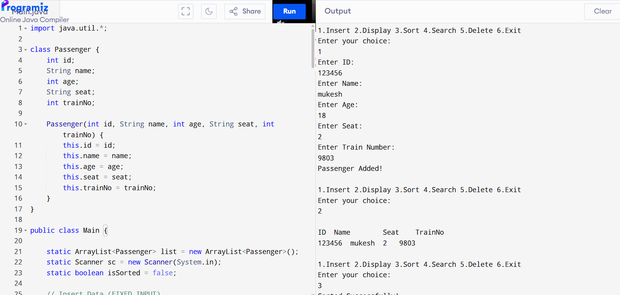

TIME COMPLEXITY:
Operation | Complexity
Insertion | O(1)
Sorting | O(n²)
Searching | O(log n)
Deletion | O(n)

SPACE COMPLEXITY:
- O(n) → for storing passenger records

ADVANTAGES:
- Fast searching using Binary Search
- Dynamic data storage using ArrayList
- Easy to implement and understand

LIMITATIONS:
- Sorting takes more time (O(n²))
- Not suitable for very large datasets

CONCLUSION:
The Train Reservation System successfully demonstrates the use of data structures and algorithms. It efficiently manages passenger records using sorting and searching techniques. The project improves understanding of algorithm efficiency and real-world applications.

REFERENCES:
- Data Structures textbook
- NPTEL lectures
- Online tutorials

